**TEAM CODESTELLATION**

**AUTOMATED RESUME SCREENING SYSTEM**

**SOLUTION DESIGN AND ARCHITECHTURE**

**SOUTION ARCHITECHTURE:**

Information retrieval (IR) models are composed of an indexed corpus and a scoring or ranking function. The main goal of an IR system is to retrieve relevant documents or web pages based on a user request. During the retrieval, the scoring function is used to sort the retrieved documents according to their relevance to the user query.

In our case, data of similar skills is available on the basis of which the mapper function is built which maps a pair of skills with the calculated similarity measure between them. Job descriptions and the set of resumes are priorly unknown and we have provided a solution based on a cognitive automation approach. Skills from the extracted text of resumes and from the job requirements are fed to the scoring function which calculates the similarity score of each resume based on the mappings obtained in the first step. Resumes are then ranked accordingly.

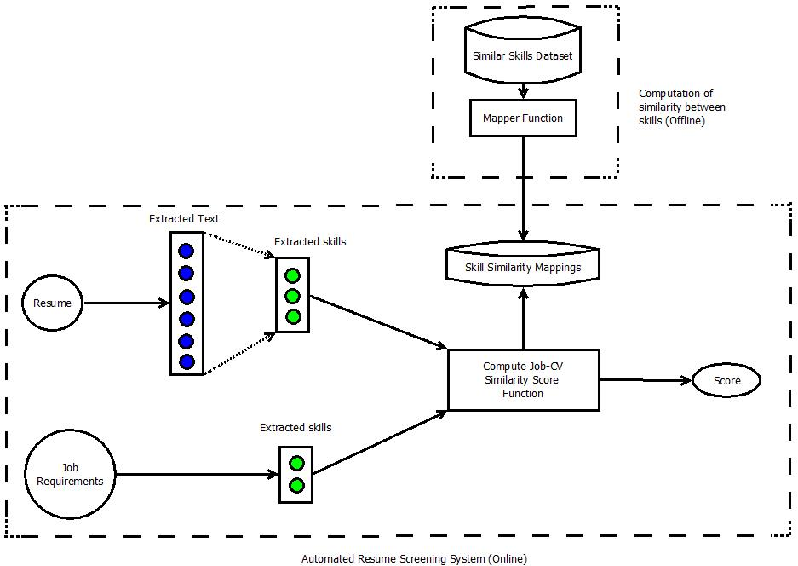

**SOLUTION DESIGN:**

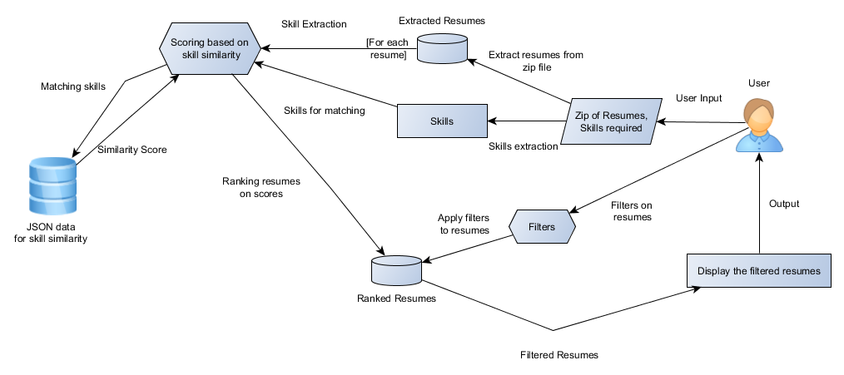

The user can upload a compressed file containing all the resumes to be screened and also provide the necessary skills as job requirements along with their priorities. The user can also provide additional filers such as number of resumes to be shortlisted, minimum education required and so on. Each resume will be analysed, and skills will be extracted. Similarity between each extracted skill from the resume and each one from the job requirement will be obtained and added to the score of that resume. The challenge we face now is to come up with an efficient solution for storage and faster access of the similarity mappings between skills, which we are currently working on. Finally the ranked list of resumes will be displayed to the user based on his filters. We will also provide the user a downloadable csv file containing the ranked resumes with details of name, email, contact, score and the link of the corresponding resume file for storage and future use.